Mini Project 1 Report – Git(Hub) Viz

|  |  |  |
| --- | --- | --- |
| Student Name | Calvin Tan | Muthiah Nachiappan |
| Matriculation Number | A0040230H | A0094582W |

# Introduction

This visualization intends to provide a quick overview of the activities within a GitHub repository. Specifically, it focusses on

1. the comparison between the number of commits by collaborators and owners for the past 52 weeks,
2. the number of commits during different times of the day, and
3. the preferences in programming languages within an owner’s repositories.

The data for creating this visualization was readily available through GitHub’s API. For demonstration purposes, we used repositories from the owner ‘torvalds’, especially the ‘linux’ repository. Calvin handled the extraction and formatting of the data into csv files using Python script. We decided to use Tableau for creating the 3 visualizations. Nachiappan came up with 2 of the visualizations and Calvin handled the other.

# Visualizations – Purpose & Method

## Types of visualization

|  |  |
| --- | --- |
| **Objective** | **Visualization** |
| 1 | Line chart |
| 2 | Heat map |
| 3 | Bar plot, Tree map |

## Visualization 1 - Commits by other collaborators vs commits by owner

The following Python script was used to extract and format the data:

r = requests.get(<https://api.github.com/repos/torvalds/linux/stats/participation>')

data = r.json()

output = pd.DataFrame(index=range(52), columns = ["total","owner", "others"])

output.loc[:,"total"] = data['all']

output.loc[:,"owner"] = data['owner']

output.loc[:,"others"] = output.loc[:,"total"] - output.loc[:,"owner"]

output = output.sort_index(0, ascending = False)

output.to_csv("qn1_rawdata.csv", index = True)

Using Tableau, a calculated field, “Others/Owners”, was created by dividing ‘others’ column by ‘owners’ column. The index (0 to 51) which represents the weeks were set to be the horizontal axis of the line chart. On the top half of the line chart, the number of commits by the owner and others were shown together using the dual axis feature. The owner commits line was coloured green and others’ commits line was coloured red. On the bottom half, the ratio of others’ commits to owner’s commits across weeks was shown. The line was coloured according to the number of commits made by the owner. The visualization achieved is shown below:

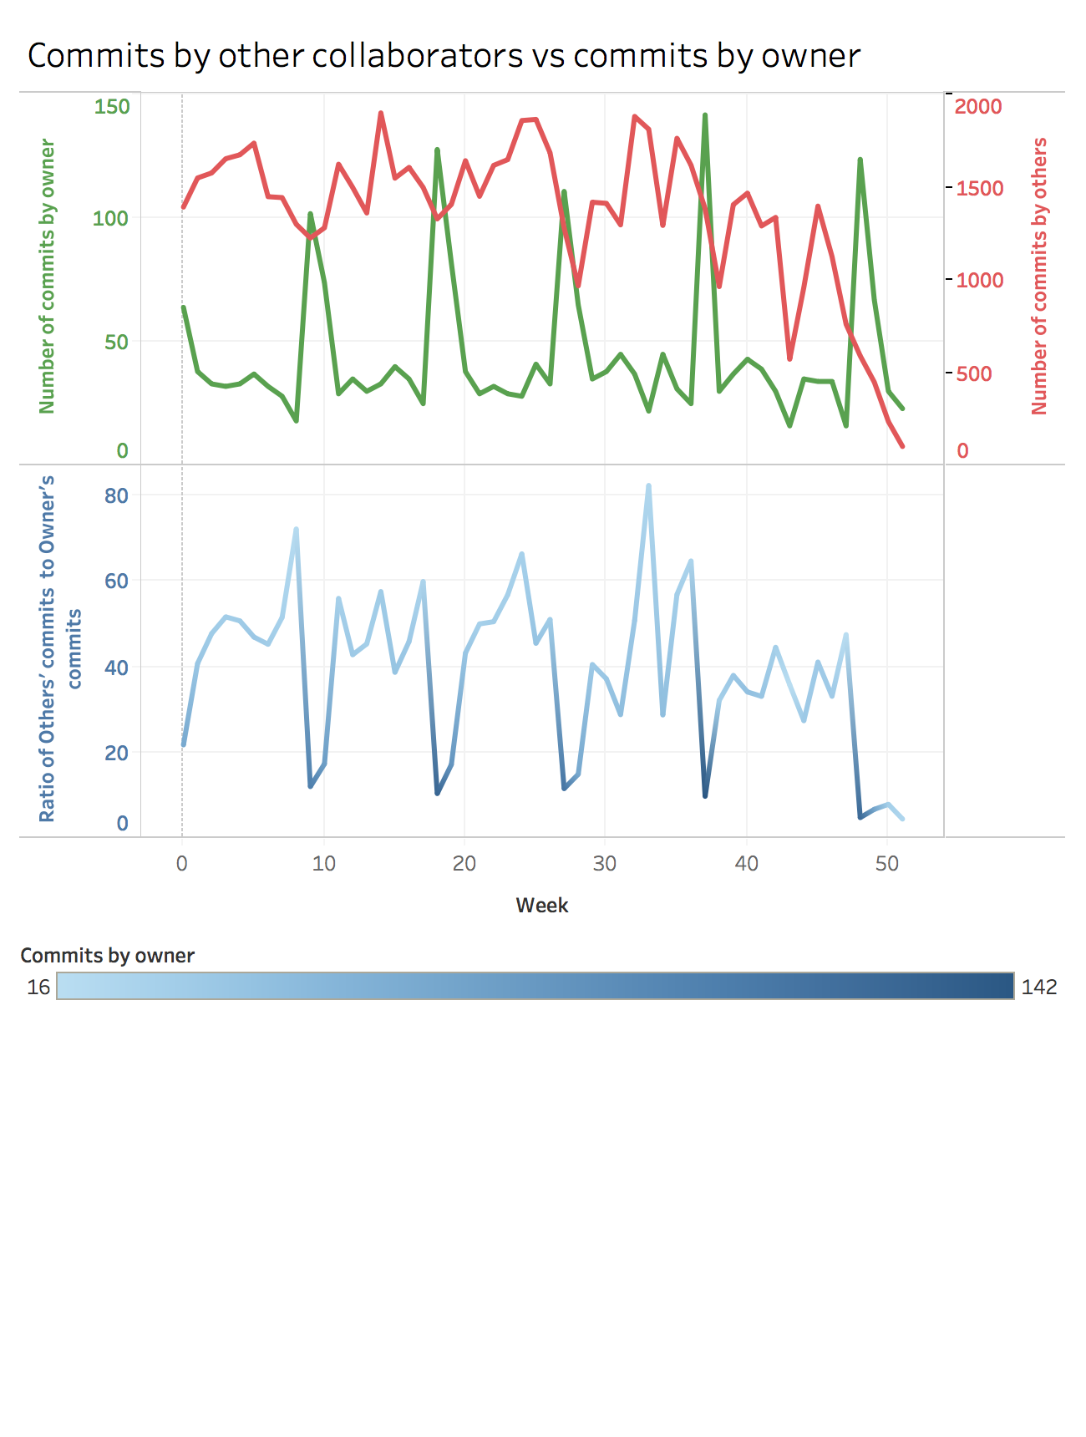

We felt that the ratio was an important component in showing how much more commits were made by other collaborators throughout the year. Interestingly, every 9 weeks, the owner made more commits and the ratio dipped. However, throughout the year, the owner’s commits were less than the collaborators’.

## Visualization 2 - Number of commits across days and working hours

The following python script was used to extract and format the data:

r = requests.get(https://api.github.com/repos/torvalds/linux/stats/punch_card')

data = r.json()

total_rows = len(data)

output = pd.DataFrame(index=range(total_rows), columns = ["day", "hour", "commits"])

for x in range(total_rows):

for col in range(3):

output.iloc[x,col] = data[x][col]

output.to_csv("qn2_rawdata.csv", index = True)

Using Tableau, the data was grouped according to day into the corresponding day’s string name. Using the day group, hour attribute and commits, the heat map visualization was selected. A filter was applied to the hour attribute to only include commits from 8am to 6pm. The days were distributed along the vertical axis and the working hours were distributed along the horizontal axis. A grey-toned single colour scale was included to show how the number of commits were distributed across the days and hours. The visualization achieved is shown below:

